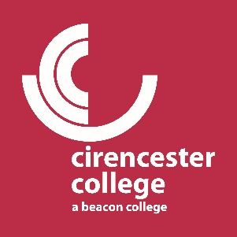

Below, you will find information related to the two teacher training courses provided at the college. If you wish to enrol, please click this link.
If you have any further questions after reading, please contact the programme leader at: Daniel.vaughan@cirencester.ac.uk

Level 3 Award in Education
The level 3 award in education is an introductory course to the teaching sector and covers the fundamentals of teaching delivery in the further education (post-16) sector. It’s suited for people who may be running teaching/training workshops, or who may be teaching assistants looking to develop their practice. It runs from September-January and is assessed with one large assignment, including an observed micro-teach assessed by your peers.
All sessions are Monday evenings from 17:15-20:15

Level 5 Diploma in Education and Training
The level 5 diploma in education and training is a qualification designed to make you a qualified teacher in the further education (post-16) sector. It’s suited for graduates looking to start teaching or individuals with a lot of industry experience looking to make the switch to teaching. It runs over a two-year period, starting every September. It is assessed with several written assignment tasks, as well as eight hours of lesson observations. Alongside this, you will need to have (and evidence in a portfolio) one hundred hours of teaching practice where you are teaching lessons, over the two-year course.
All sessions are Monday evenings from 17:15-20:15
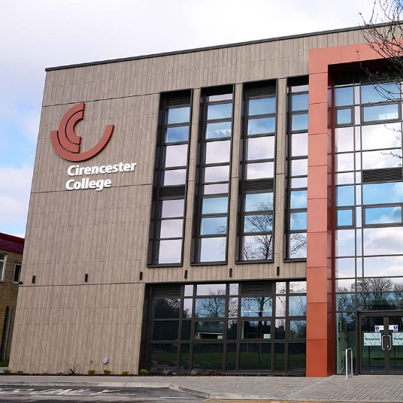
Entry Requirements?
For the level 3 award, you will need to evidence completion of 5 GCSES at grade 4 (or Cs) or above. This will need to include maths and English.
For the level 5 diploma, you will need to have either: an undergraduate degree, or significant industry experience, as well as GCSE English and Maths.
Both courses require an entry interview and CV

