Cirencester College Strategic Plan 2025–2030
(2026 Beta Update)

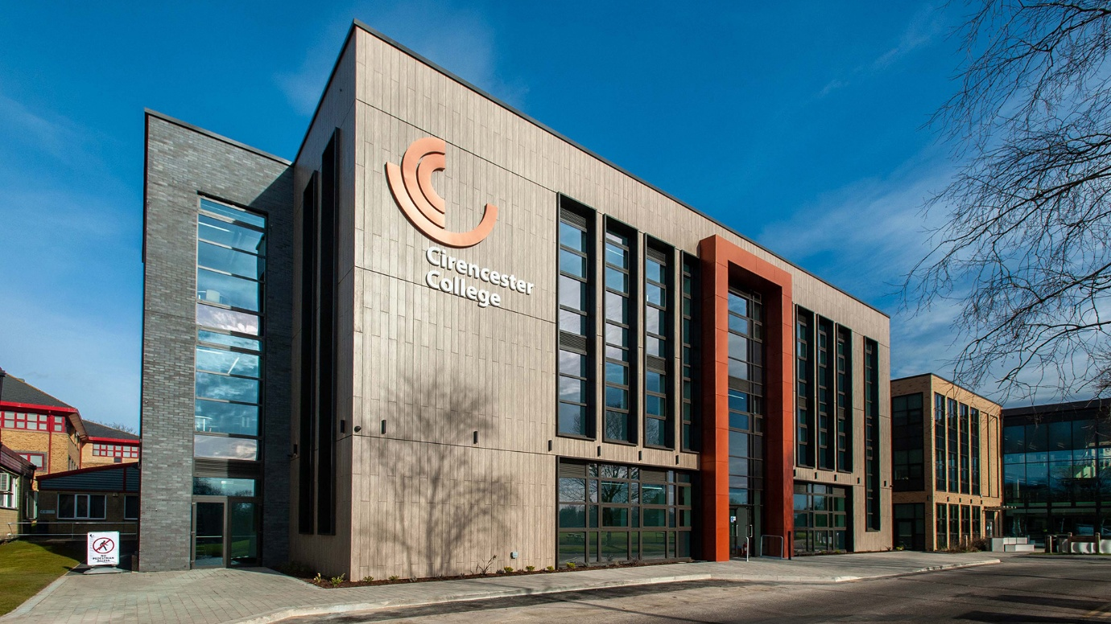

Foreword
Cirencester College has a proud reputation for educational excellence, innovation and student success. As we look towards 2030, we recognise that the world our learners are entering is changing rapidly. Advances in technology, evolving workforce needs, environmental challenges and shifting societal expectations require education providers to be increasingly agile, ambitious and forward-thinking.
This Strategic Plan sets out our priorities for the next four years. It places the Cirencester College Learner at the heart of every decision we make and provides a clear framework for how we will continue to deliver outstanding education while preparing learners for successful futures.
Our strategy is built around three interconnected themes:
Excellent Future Ready Learning
Student Success: Holistic Development
Partnerships and Profile
Together these themes provide a coherent framework for delivering our mission, achieving our vision and creating positive impact for learners, staff, employers and our wider community.

Vision
To be recognised as a beacon of innovation, inclusivity and academic excellence.
Mission
To fully prepare learners to progress to their next stage, be that education or employment, by delivering excellent educational programmes.

People
The Cirencester College Learner
At the centre of our strategy is the Cirencester College Learner. We aim to develop learners who are academically successful, independent and resilient, digitally confident, and socially responsible. In addition, we want our learners to be curious, ambitious for their future and career ready.
The Cirencester College Teacher
The Cirencester College Teacher is academically successful, a pro-active and positive problem solver, resilient, kind, digitally confident, and socially responsible. In addition, we want our teachers to be collaborative, caring, knowledgeable, curious and absolutely student focussed.
The Cirencester College Support Staff
We are one Community. Our support staff are valued and respected and partners in our endeavour. They are qualified specialists, knowledgeable, resilient, kind, positive, curious and socially responsible. In addition, we want our Support Staff to be contributing to development, ambitious and involved in the wider College.
The Cirencester College Manager
Driving the centre of our strategy is the Cirencester College Manager. We aim to develop Managers who are highly competent, curious, caring, positive, creative, solutions focussed, collaborative and example leaders. In addition, we want our Managers to be non-siloed, supportive to peers, kind, open minded and willing to learn.
We acknowledge and facilitate these roles through mutual support, staff development, comprehensive training and a culture of sharing.

Theme 1: Excellent Future Ready Learning

Priority 1: Teaching and Learning Excellence
Outstanding teaching remains the single most important factor in learner success.
We will deliver consistent high-quality teaching, learning and assessment to ensure excellent learner outcomes across all provision. We do this by embedding evidence-informed practice, developing learners' critical thinking, communication and problem-solving skills, and by Fostering independence, resilience and intellectual curiosity.
Success by 2030 will look like:
Achievement rates remain significantly above national benchmarks.
Positive value-added outcomes across programmes.
High levels of learner satisfaction.
Strong progression into higher education, apprenticeships and employment.

Priority 2: Digital Empowerment
Technology will transform education and employment during the lifetime of this strategy.
Our strategic objectives encompass developing advanced digital literacy for all learners, integrating AI and emerging technologies responsibly, equipping staff with confidence and expertise in educational technology, improving efficiency through digital systems and automation, and finally by promoting safe, ethical and professional use of technology.
Success by 2030 will look like:
Digital skills embedded across all curriculum areas.
Learners demonstrate confidence in AI-assisted environments.
Staff utilise technology effectively to enhance learning.
Streamlined digital processes improve organisational efficiency.

Priority 3: Innovation and Research
Innovation is essential to maintaining relevance and excellence.
We will achieve this by fostering a culture of innovation and experimentation which encourages engagement with educational research and participation in national and regional projects. We will share best practice across the organisation and promote continuous improvement through reflective practice.
Success by 2030 will look like:
Increased staff engagement with research activity.
Recognition for innovative educational practice.
Strong contribution to sector development initiatives.
Continuous improvement evidenced through outcomes and feedback.

Theme 2: Student Success: Holistic Development

Priority 4: People and Culture
Exceptional learner experiences depend on exceptional staff.
We will achieve this by creating a positive, progressive and inclusive culture where we invest in professional development. We develop our future leaders and actively support staff wellbeing. We will robustly protect our culture of collaboration and innovation.
Success by 2030 will look like:
High staff engagement and retention.
Strong leadership capacity.
Positive organisational culture.
Recognition as an employer of choice.

Priority 5: Responsible Growth
Growth must be sustainable, purposeful and aligned with need.
We are respond to regional and national skills priorities and will actively map our provision against these. We will maintain a broad and accessible curriculum and Support widening participation. We will expand opportunities where demand exists and Protect educational quality during growth.
Success by 2030 will look like:
Sustainable growth in learner numbers.
Strong progression pathways.
Improved access for underrepresented groups.
Curriculum aligned to labour market demand.
Priority 6: Finance and Resources
Strong finances enable investment in learners.
We will maintain financial resilience and invest in our high-quality learning environments. We will ensure efficient resource management and deliver value for money while maintaining modern and sustainable facilities.
Success by 2030 will look like:
A strong and stable financial position.
High-quality learning spaces.
Modern infrastructure supporting teaching and learning.
Long-term organisational sustainability.

Theme 3: Partnerships and Profile

Priority 7: Industry Collaboration
Employers play a critical role in preparing learners for the future.
We will strengthen our employer partnerships to the level where they are engaged in the design of curriculum where appropriate. Our relationships will increase workplace learning opportunities and expand industry engagement activities. Exposure to this opportunity will improve learner understanding of career pathways.
Success by 2030 will look like:
Strong employer engagement across curriculum areas.
Increased work-related learning opportunities.
Enhanced employability outcomes.

Priority 8: Stakeholder Engagement
Collaboration strengthens outcomes for learners.
We will develop stronger relationships with schools and strengthen university partnerships, to better understand and support the flow of our learners through their academic careers. We will further build community engagement and promote international perspectives and opportunities.
Success by 2030 will look like:
Strong progression partnerships.
Increased collaborative activity.
Enhanced reputation and visibility.

Priority 9: Social Responsibility
We have a responsibility to future generations.
We will reduce environmental impact, promote sustainability and champion equality, diversity and inclusion. As an integral part of our town and local area we will support community engagement and develop socially responsible citizens.
Success by 2030 will look like:
Reduced carbon footprint.
Increased sustainability awareness.
Stronger community partnerships.
Positive contribution to local and global challenges.

Enablers of Success
To deliver this strategy we will put learners first and lead with integrity. We will use evidence to inform decisions and embrace innovation. Our forward thinking attitude must be one of positivity, collaboration and enthusiastic support for each other. We must remain curious, kind and supportive of positive change. Negativity requires challenge. We must promote collaboration and invest in people while managing resources responsibly. A collegiate and positive supportive attitude to our work will foster inclusion and belonging.

Measuring Success
Progress will be reviewed and monitored annually through our reporting systems and KPI matrix. Our ultimate focus must be on learner achievement and progress, and this will be supported by paying close attention to attendance and retention, progression destinations, employer engagement and staff engagement and retention. As a business we will also ensure success by reviewing and monitoring our financial performance, sustainability indicators, stakeholder feedback and quality assurance outcomes.
Governors will receive regular updates against strategic objectives and key performance indicators to enable them to effectively challenge and guarantee assurance.

Looking Ahead
By 2030, Cirencester College will be recognised not only as an excellent place to study and work, but equally for outstanding academic outcomes and for developing confident, capable and future-ready young people.
Through excellent learning, holistic development and strong partnerships, we will continue to transform lives, strengthen communities and provide exceptional opportunities for every learner. The Cirencester College Learner, and our continual questioning of “What is the impact on the learner”, will remain at the heart of everything we do.


Matt Reynolds
Principal and CEO
Cirencester College

